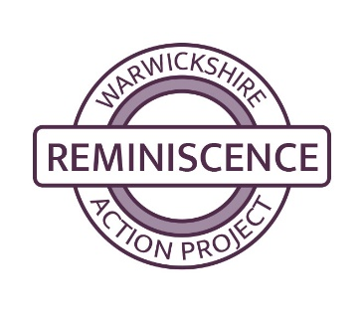
WRAP Memory Box Feedback Form

Organisation
Date Borrowed
Box Number
Box Name
How many people attended the session(s)?
Who led the session?
Did any particular item(s) promote interest/discussion?
What memories/topics did it bring up?
Did everyone join in with the session?
Did people have to be led into participating or did they just join in?
How can the box and/or our service be improved?
Was there anything missing from the box?
Please use this box for any other comments
It is useful for us to get feedback on the benefit of our service. Please use this space to leave any comments.
It is useful for us to get in depth feedback to use to develop the charity. Please use this space to leave a testimonial.

Thank you for completing the form – it really helps us to evidence the value of this scheme.

Rev May 2025

